Login/register pop up:
- https://sharp.ca/en/login/ (confirming this page will not disappear)
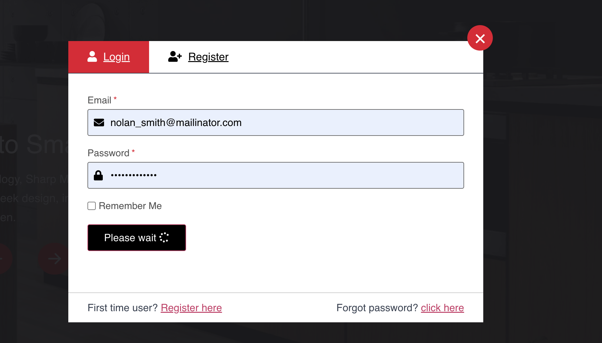


- Can we update the tab to have the same image and text as the current SRC? Call it Sharp Partner Central


https://srcci4.betademowork.com/en
- Under downloads and technical bulletins, there is some text ‘App.SHOWING_FROM_TO_END_OF_TOTAL’ showing. It should show ‘showing 1 of X’
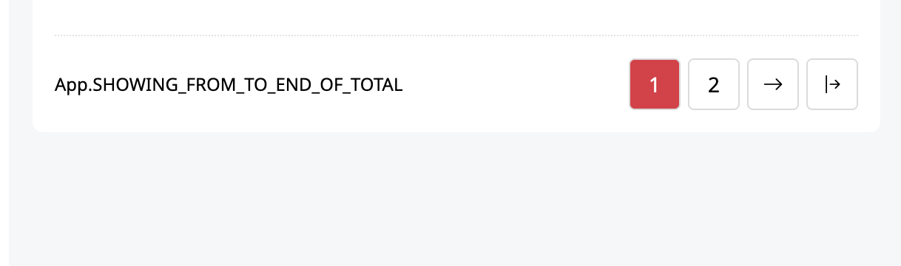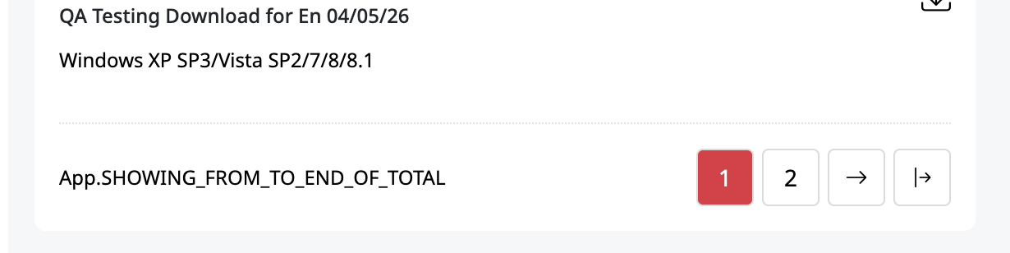

- French translation:
- Dashboard should be: Tableau de bord
Question: For French translation can Sharp admin go in and make the changes, or do we need to provide the list to the dev team?

- Where it says product line, can we rename to Group/Groupe?
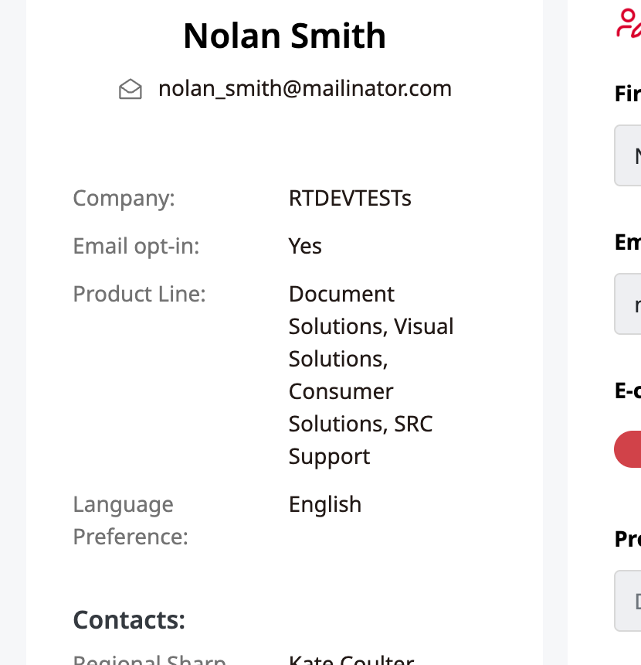

- Guides are not showing up on the SRC for printer products.
https://sharpci4.betademowork.com/admin/products/edit_product/2113
https://srcci4.betademowork.com/en/products/details/business-copiers-printers-bpc545pw

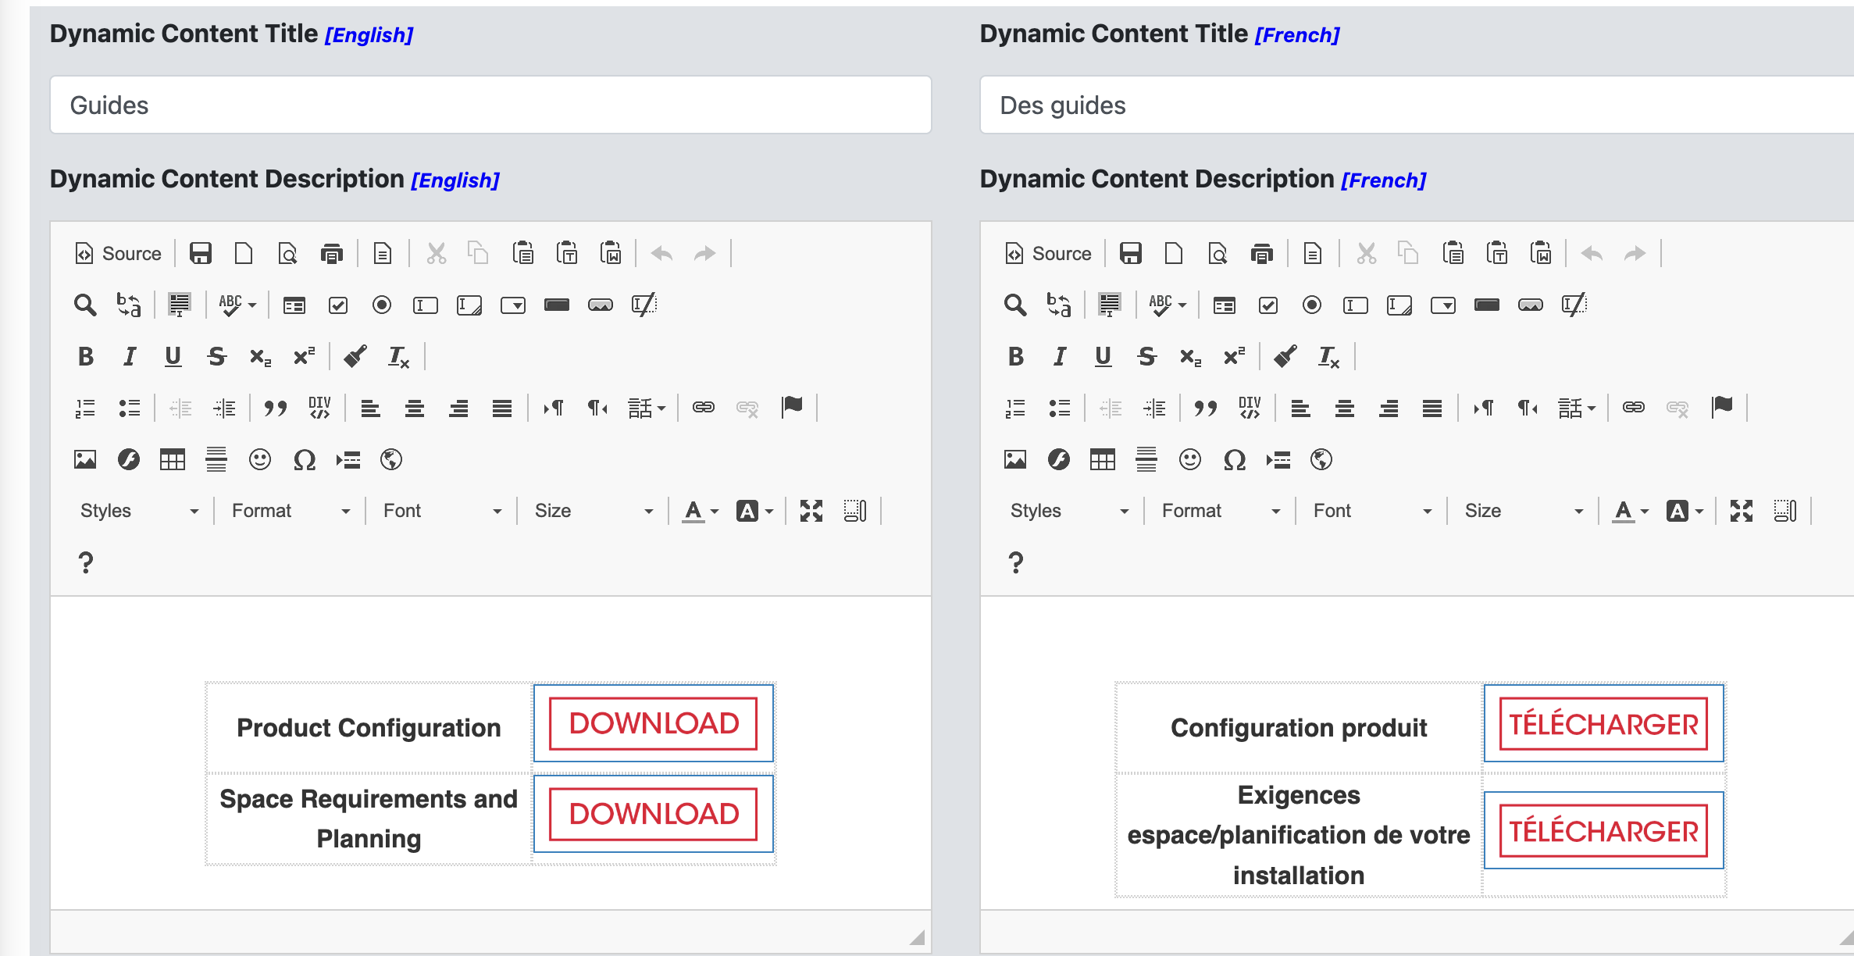

https://sharpci4.betademowork.com/uploads/product_downloads/BPC545PW_BPB550PW_EN.pdf
- When testing downloads and documents I receive an 404 message when trying to download the pdf from the product page.
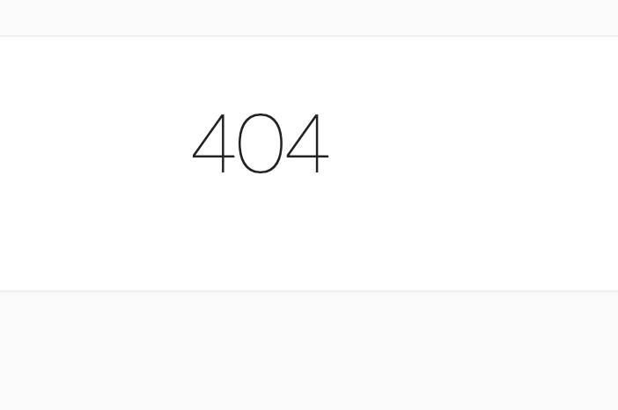

- When on the home page, and on an extended screen or mobile can the message centre box algin at the bottom to the Technical Bulletins?
Extended: 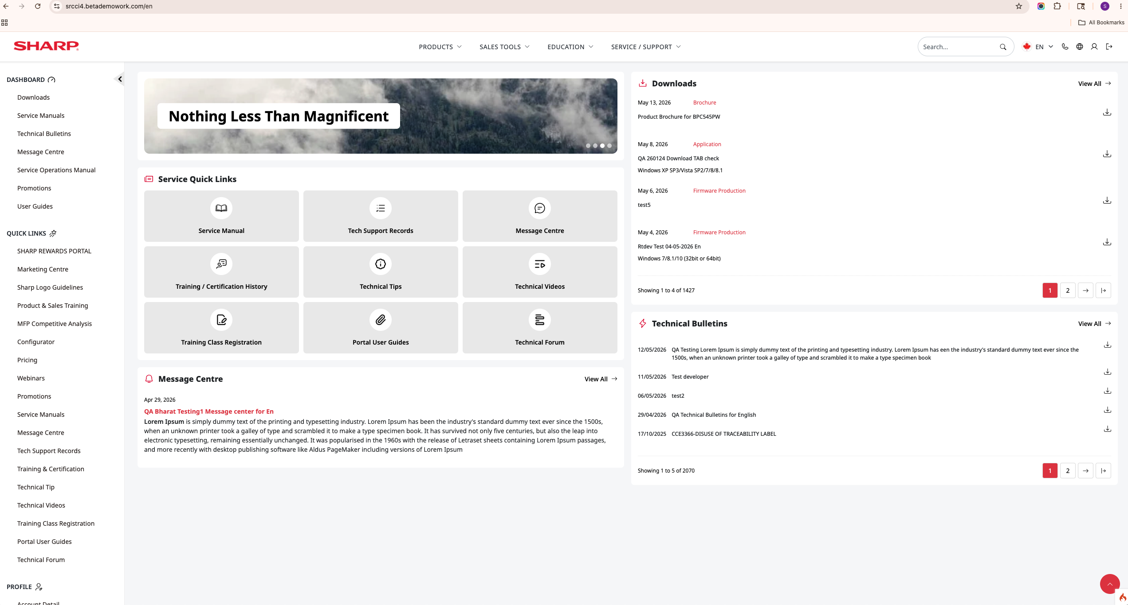
Desktop Laptop:
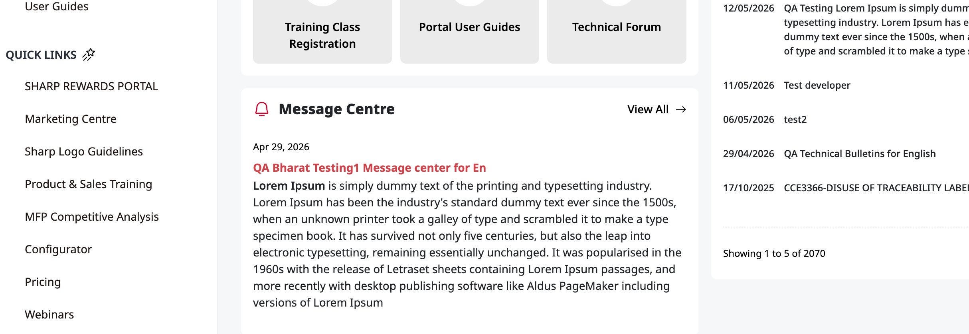
- In the edit profile tab:
  - permissions should not be available to the user to switch/change.
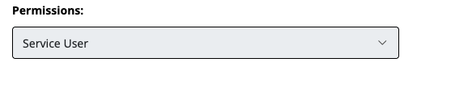
  - E-commerce Opt-in should be renamed to Email Opt-in.

  - Reset password: spelling on ‘Confirm New Password’
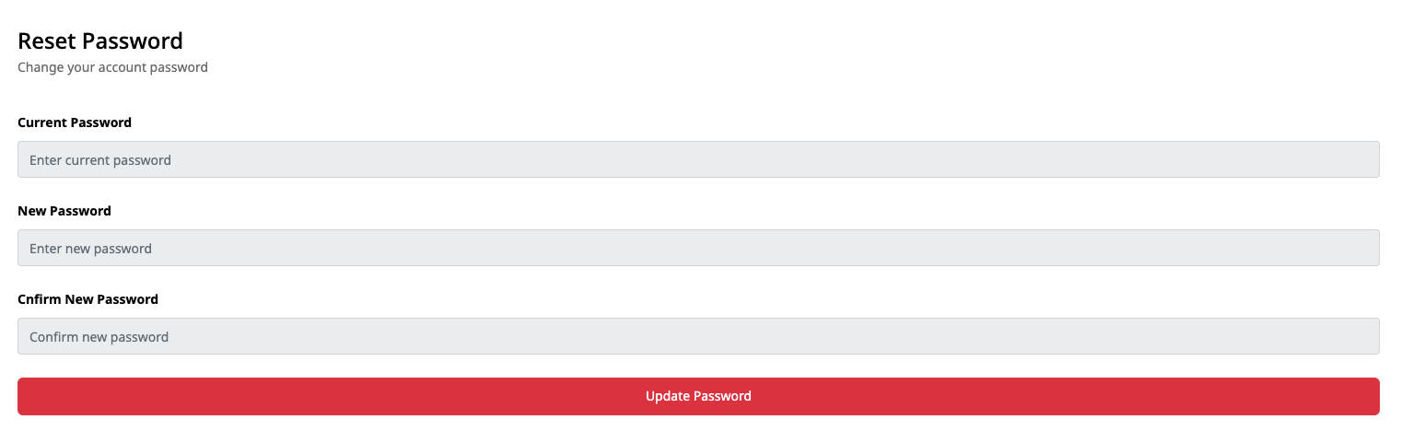
- Downloads
  - https://srcci4.betademowork.com/en/downloads for permissions, only show what categories the user has permissions for.
  - I added a document to current BP71C55 and it’s not showing up in the downloads.
https://sharpci4.betademowork.com/admin/products/edit_product/2179
Also added a new model ‘testttttsssssss’ and the documents or model is not appearing in the downloads section.
https://sharpci4.betademowork.com/admin/products/edit_product/2219
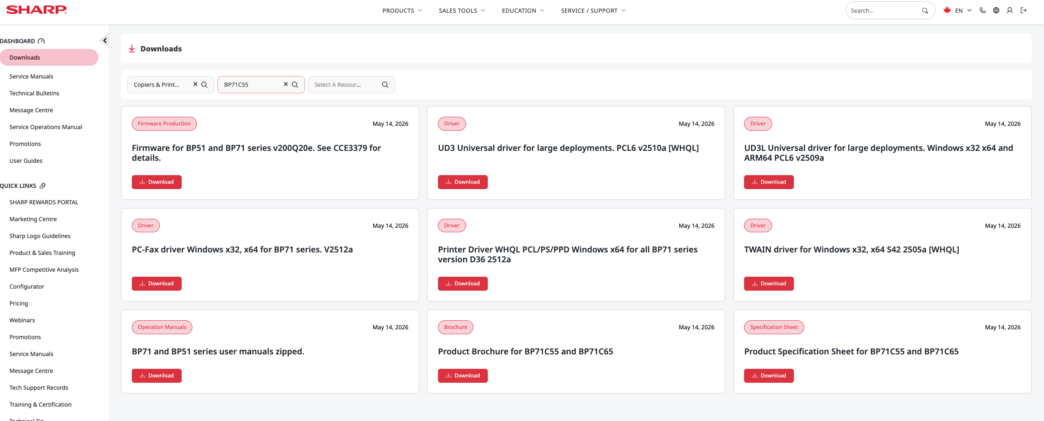
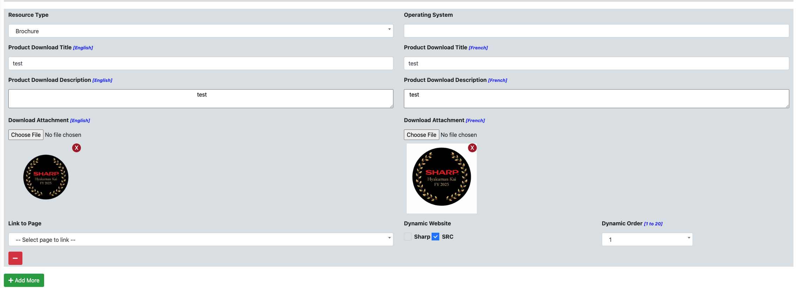
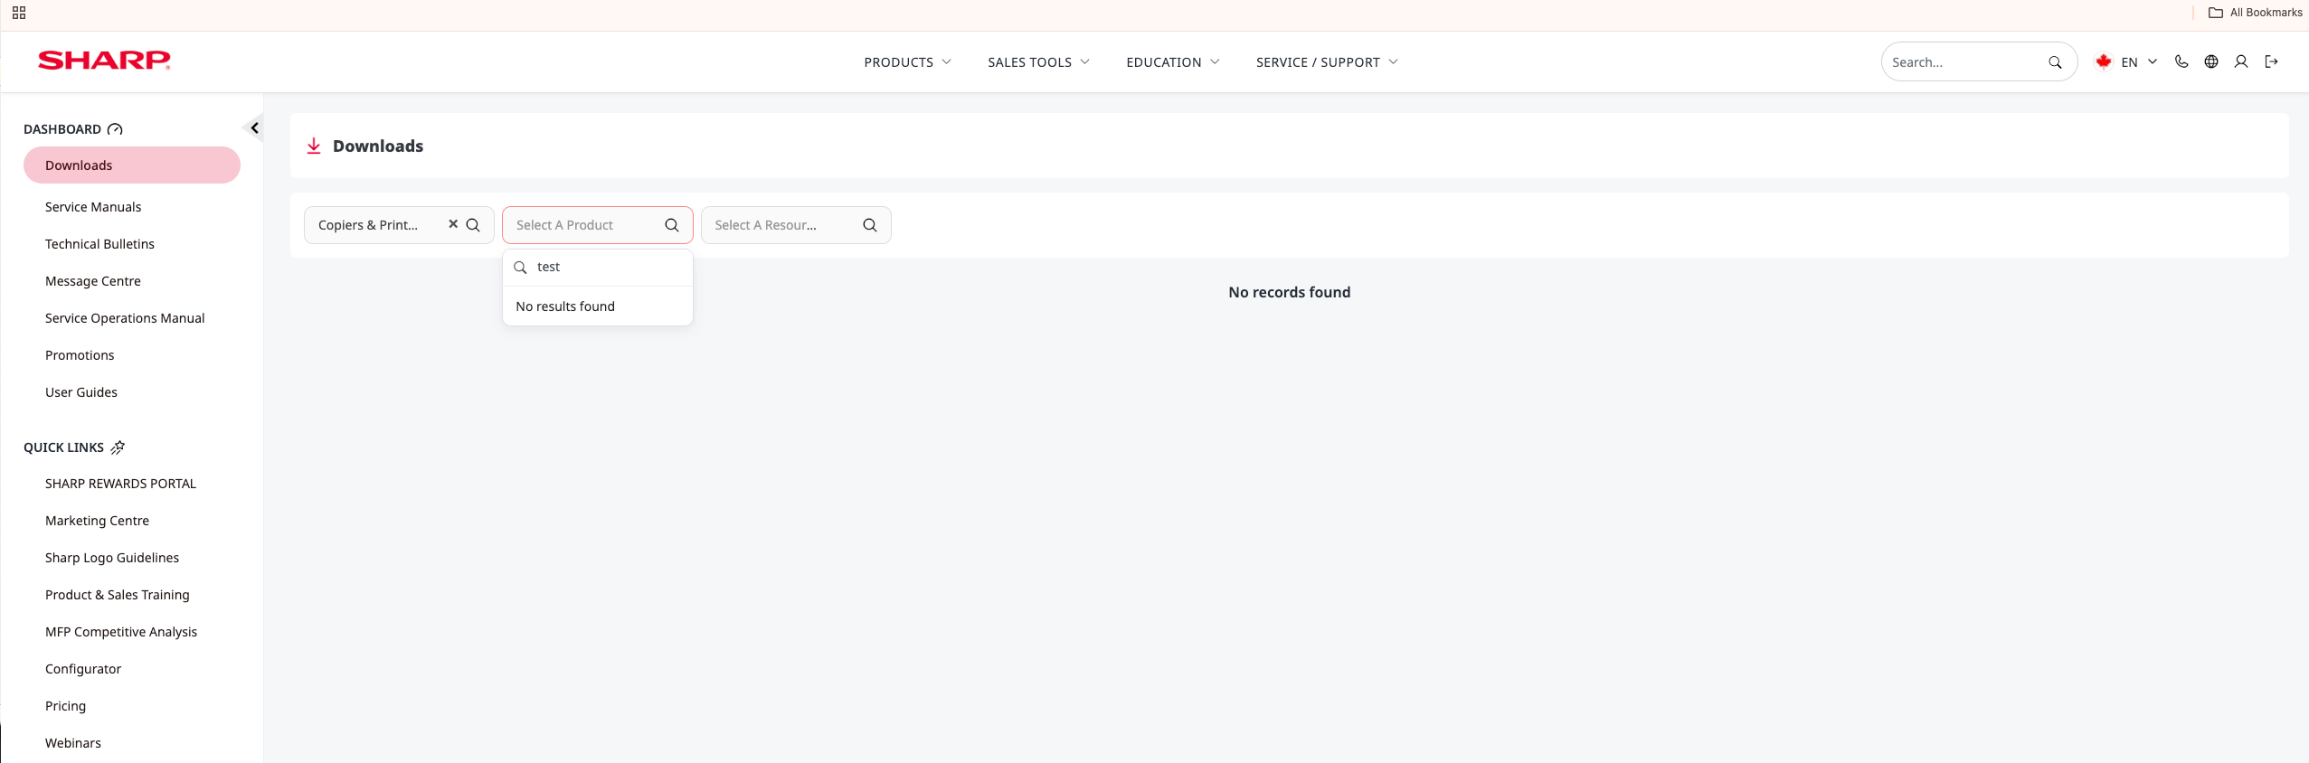
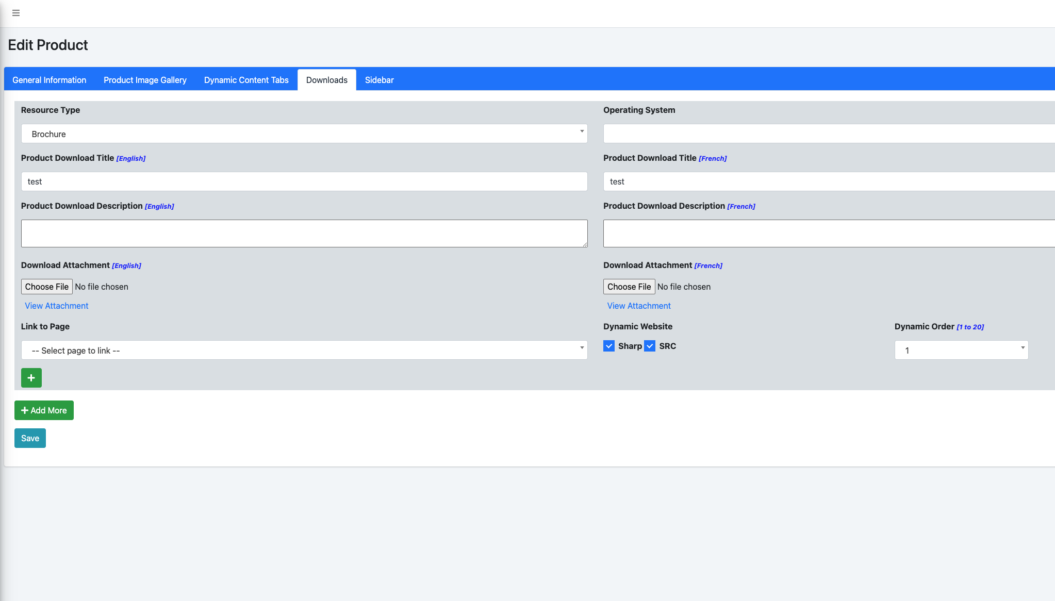

- Reviewing the flow chart pg. 8 – what are the instructions for “For Copiers / Printers – add a tab on the product pages for ‘Product Configurator’ that links to a 3rd party website (tab acts as button). Link should be editable per product”.
- Why is Product Image in a separate tab from the General information? See 4iii for more context.
- Homepage permissions issue: On ticket 237.
- Homepage: We need to be able to add the Partner Central logo in addition to the SHARP logo. Can we add a place holder logo in the navigation about the slider?
  - 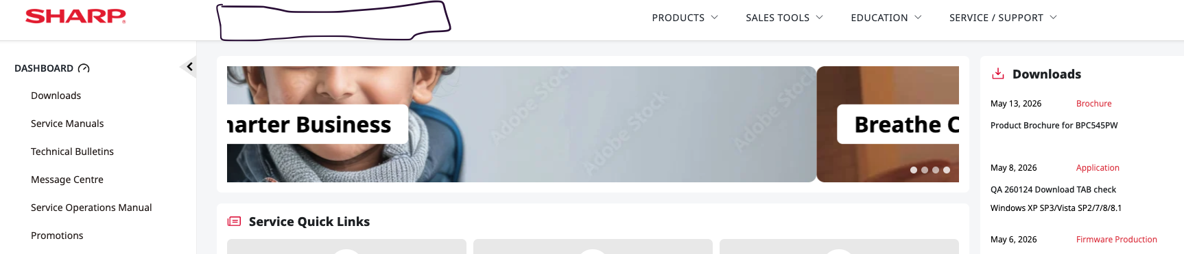
- Sales Tools 3.0
  - Message Centre 3.1
    - Works.
    - Can we add a back button to go back to message Centre or use title as a way to go back?
    - Read article should be read more /. Lire la suite. And open the PDF in another tab.This will create a better user experience and less step to read the document. Same function as the case studies.
  - Collaterals & Document Library 3.2
    - https://srcci4.betademowork.com/en/collaterals-document-library
      - Why is there sometimes an author and sometimes now. For consistency remove author from front end.
      - In the category section, can we add ‘all’.
      - Only categories that the user has access should show.
      - Latest upload should be showing first.
      - On our current SRC we can add an image. This feature shouldn’t disappear on the new version.
        - Example:
          - 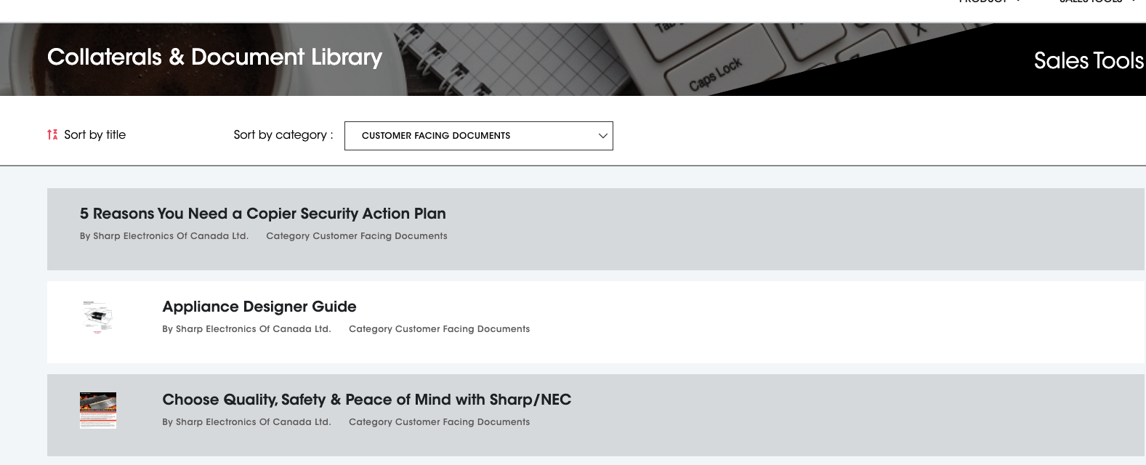
  - Awards Gallery 3.3
    - Award categories should only show up if there is an award available.
    - When I try to make my own test, there is a lag when selecting the category and then model. Sometimes the model does not come up. Example: Copiers & printers -> type in any BP model and it shows no models. It’s a hit a miss. Could be due to this being a demo site, but wanted to flag.
    - Also, when trying to type in a model in the back end, sometimes I’m getting the following error message: 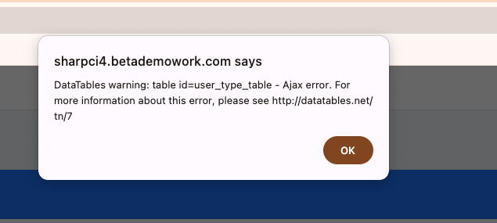
  - Sharp License Portal 3.4
    - This is a 3rd party link. Confirming, the team did not create anything else?
      - Change: can this open in a new tab vs current?
  - Pricing 3.5
    - Latest upload should be showing first.
  - Video & Image Library 3.6
    - When the user selects the category, only the models for that category should appear.
    - Also, if the user only has permissions to DS, CS, VS etc, they should only see those categories.
    - The images that are on sharp.ca should be carried over onto here and the product image gallery should be additional images to add for SRC specifically?
  - White Papers 3.7
    - Latest upload should be showing first.
    - Assuming this section is : sales tools > A/I/W Papers, can we rename it White Papers?
    - In the dropdown, can we add ‘all’
    - Since we have the category drop down, we do not need the category duplicated into each content box.
  - Promotions 3.8
    - Latest upload should be showing first.
    - Can add sort by title and sort by date?
  - Vertical Markets 3.9
    - Is there a better way to upload the content? Do we have to add the content in the content box, or can we add multiple files to the associated files section?
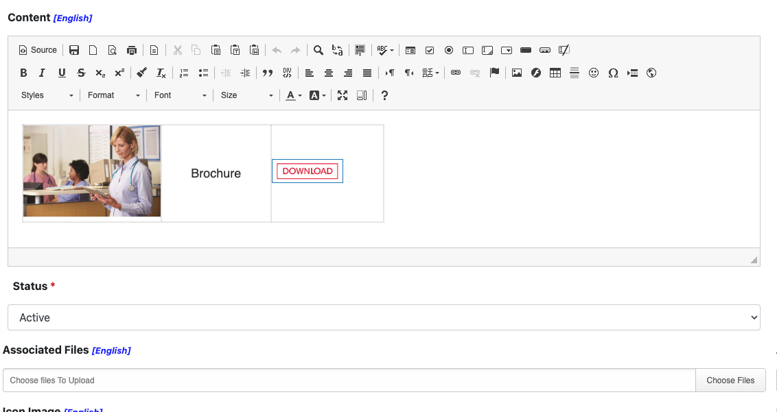
  - Case Studies 3.10
    - Latest upload should be showing first.
    - Remove author.
    - Can we add images like we have for white papers?
  - Digital Signage Contents 3.11
    - Latest upload should be showing first.
    - For the open content button, can it not be mandatory to provide a website link?
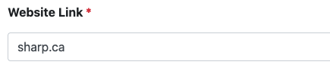
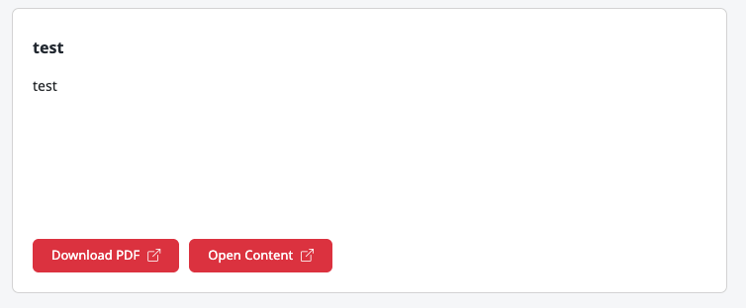
  - Presentation Orders Folders 3.12
    - Remove the category and model from the front-end boxes.
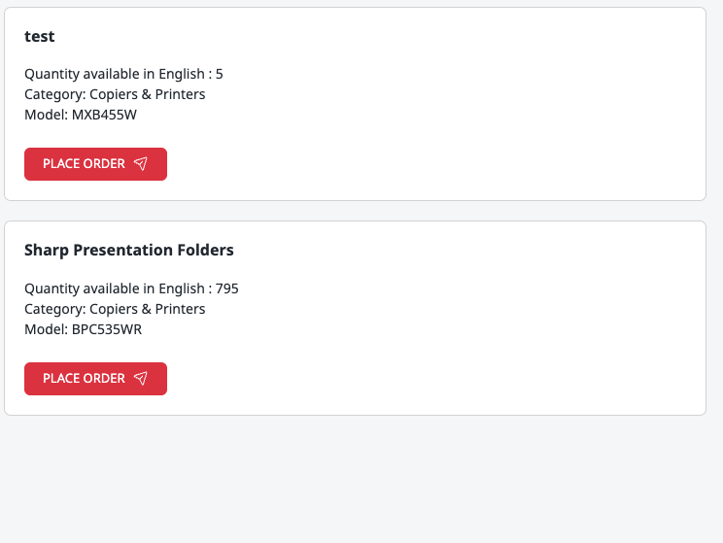
    - Where can we update the email address to receive these requests?
    - Is it possible to add a section at the top to filter by category and model?
- What are we doing with section and sales tools > competitive analysis?
- User Guides & Promotions:
  - Can the layout be the blocks per item to download.
    - 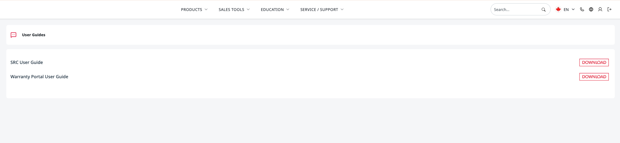
    - Use the first option of the download page on canva.
- At milestone will we be able to change the dashboard and quick links on the left navigation bar?
- If there is a form error on the back end, instead of the system removing the content, can it keep the content but still flag what was missed? This avoids having to re do everything and just flag the field that was missed?
- https://sharpci4.betademowork.com/admin/setting_src/general
  - Could we repurpose the unused section below as a pop-up notification area? For example, if we are making updates, adjustments, or addressing issues on the SRC/Partner Portal, a pop-up message could appear when users log in. Users would then need to click the “X” to close the notification before continuing.
Old:
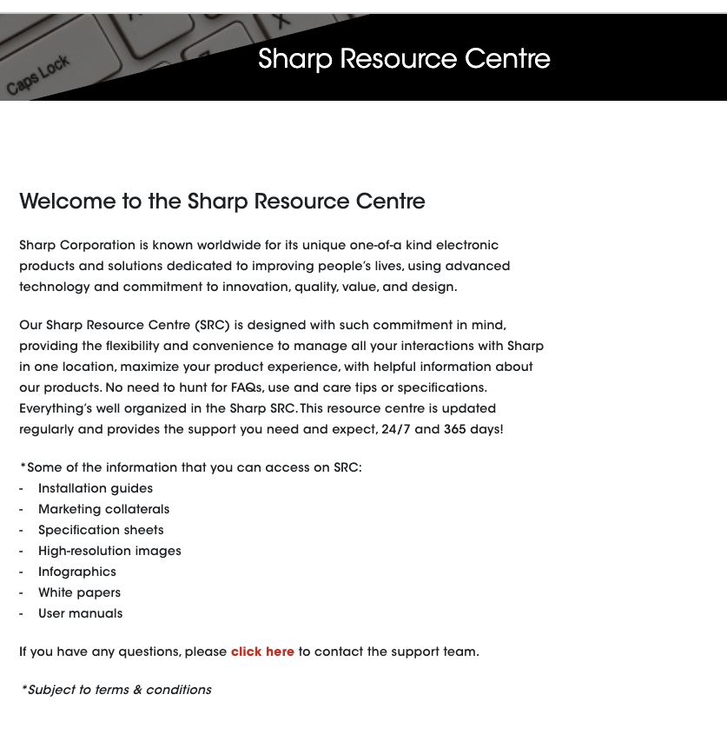
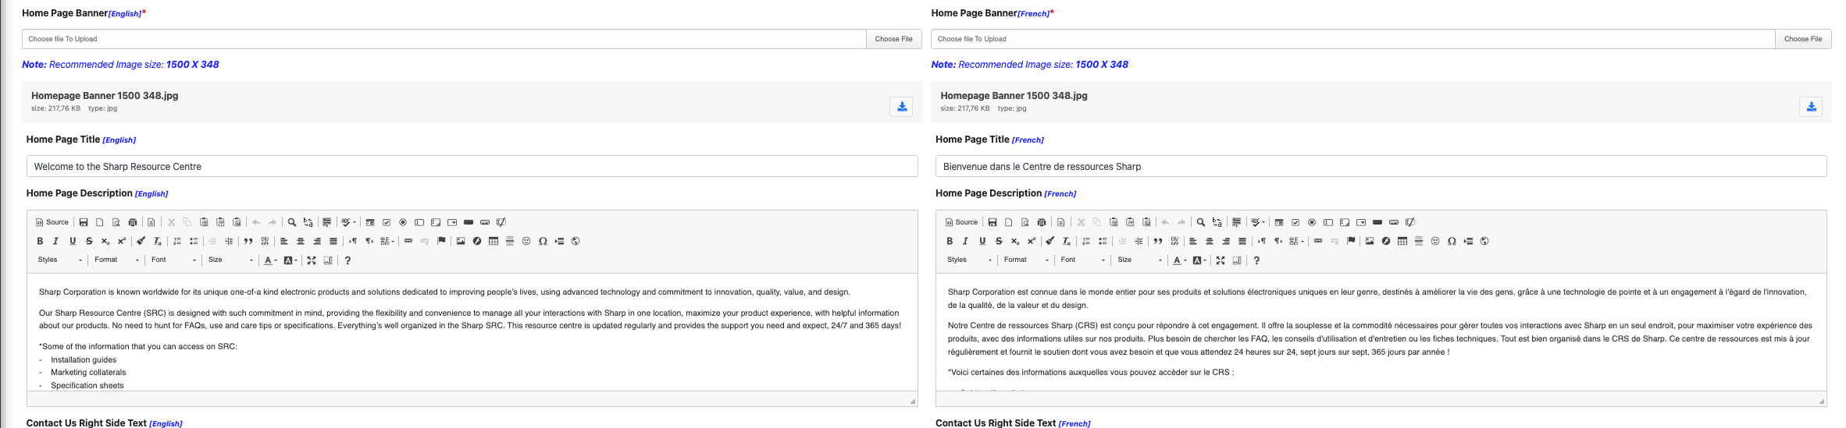
new: